
Housing all Washingtonians
HOUSING IS EXPENSIVE
 1.1m
new homes are needed to accommodate Washington state’s projected population growth over the next 20 years.⁵

People who live in our state rank housing costs as one of the top problems in the state, according to a 2022 survey by the state Department of Commerce and the Puget Sound Regional Council. About 76% of residents statewide said they have been directly impacted or knew someone who was affected by housing costs and availability.
The cost of homes in the United States has outpaced wage growth––home prices rose 74% from 2010 to 2022. The average wage rose only 54% during the same time. Rents are up too. The U.S. Census Bureau has found the median gross rent in Washington to be nearly $1,500, ranking it among the top five states in the U.S.
HOUSING IS IN SHORT SUPPLY
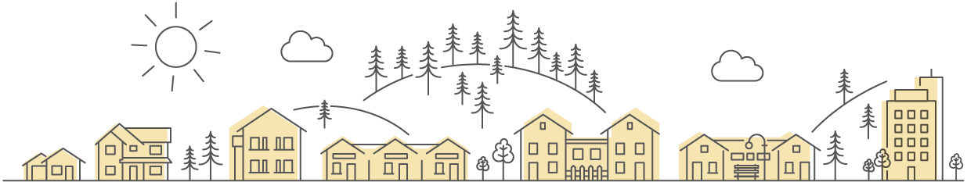
Part of the reason for high housing costs is that our population has been steadily growing, but our housing supply has not kept up. To keep up, between 2000 and 2015, our state should have produced 225,600 more units that we did. In the next 20 years, we expect our population to continue to increase by more than 1.5 million people. The Department of Commerce has projected we will need 1.1 million additional homes to house everyone.
Many communities across Washington have a variety of different housing types, from single family homes, to duplexes, to backyard cottages. A mix of housing types in a neighborhood creates more inclusive and thriving communities.

DIVERSE HOUSING NEEDS REQUIRE MORE
HOUSING OPTIONS
 70%
of housing in Washington state today
is zoned as single-family homes.⁶
Demographics in our state have changed too. According
to the U.S. Census Bureau, about 28% of households today are one-person households. And by 2030, the Bureau predicts about one in five Americans will be 65 years of
age or older. These trends are partly behind our state’s
need for more units of smaller size.
In the Department of Commerce’s statewide 2022 Housing Survey, we learned that more than 3/4 of Washingtonians want more housing options for all people in their communities, including seniors, teachers, firefighters, childcare workers, and healthcare workers. And 83% of Washingtonians say more reasonably-priced housing is needed in their communities to meet these diverse needs.
BY ADDING TO OUR HOUSING SUPPLY, WE CAN HELP EVERYONE TO FIND A HOME THEY CAN AFFORD
Most cities and counties in Washington are required to update their comprehensive plans and local codes to accommodate more diverse types of housing. They will be considering changes that can provide more housing in existing communities, and you are needed too.
Your name here
Your title goes here
Division, City, or County here
Firstname.lastname@commerce.wa.gov
Phone: XXX.XXX.XXXX
Cities and counties across Washington are working to update
their plans and regulations to meet our housing needs.
Learn more about housing in your community, and how you
can help from the Washington State Department of Commerce
at www.commerce.wa.gov/planning-for-housing

Your name here
Title
Division, City, or County
name@commerce.wa.gov
(XXX) XXX-XXXX

Puget Sound Regional Council & Washington State Department of Commerce December 2022 Housing Survey (psrc.org)
USA Facts, Home Prices are Rising Faster than Wages April 2023 (usafacts.org)
U.S. Census Bureau Quick Facts (census.gov)
Up For Growth 2022 Housing Underproduction in the U.S. (upforgrowth.org)
Washington State Department of Commerce, Projected Housing Needs March 2023 (commerce.wa.gov)
Washington State Department of Commerce, Projected Housing Needs March 2023 (commerce.wa.gov)
Puget Sound Regional Council & Washington State Department of Commerce December 2022 Housing Survey (psrc.org)

