
We Need More Housing in Washington State
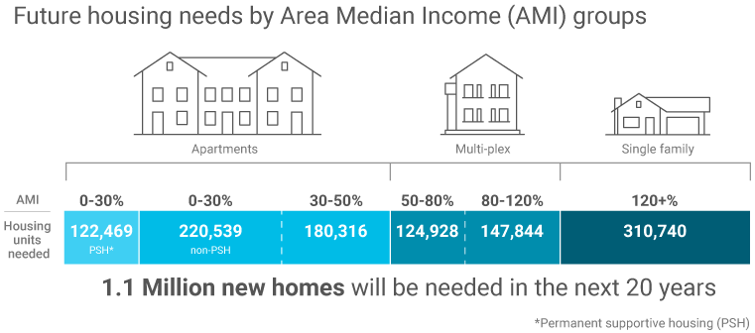
WASHINGTON’S POPULATION IS GROWING, BUT OUR HOUSING SUPPLY HASN’T KEPT UP
There’s a lot we all love about Washington, from its natural beauty to our strong economy. The things we love have attracted a growing population and increased the demand for housing in our state. With more people bidding on our short supply of existing housing, the price has increased. In the next 20 years, we expect our population to increase by over 1.5 million people. The Department of Commerce has projected we will need 1.1 million additional homes to accommodate the current housing gap and our future population.
HOW WE PLAN FOR HOUSING
The Growth Management Act requires cities and counties to assess housing needs and plan for and accommodate housing for all economic segments of our population. Cities and towns break down housing needs by how much of the Area Median Income (AMI) a household earns. AMI is the household income for the median (or middle) household in a region.
Today, only households that earn above 120% can generally afford a detached single-family house. Housing for this group might also be townhouses or condominiums around natural amenities or downtowns. Developers often focus on building homes for this group. Creating more housing for people in this bracket can free up existing homes for households in lower income brackets.

HOUSING MIDDLE-INCOME SEGMENTS
~36%
of Washington’s households are cost-burdened, spending more than 30% of their monthly income on housing costs like rent.3
Middle income households are those earning 50-120% AMI, who may be able to afford smaller units, such as accessory dwelling units (ADUs), townhouses, or other forms of middle housing.
A single professional earning 80% AMI should be able to afford a townhouse in their community. A young family may be able to affordable a home with an ADU to help offset the mortgage.
HOUSING THE LOWEST-INCOME SEGMENT
About half of the new homes needed in Washington are for those earning under 50% AMI. These households rent apartments, live in manufactured homes, or other subsidized forms of housing. The private market rarely provides housing for these income segments without subsidies like rent assistance.
Cities or counties may provide incentives for developers, such as the right to build extra units in a development, if they are only rented to households earning certain incomes, typically under 80% AMI. In some communities, a percentage of new development is required to be income-restricted.

HOUSING FOR ALL, AT ALL STAGES OF LIFE
Many of the residential areas across Washington state consist of solely of detached single-family housing. Because of this, many of our neighbors, like first responders, teachers, and restaurant employees, have been priced out.
As our state’s population continues to grow, it’s important to create communities that support people at any stage of life with diverse types of housing. Building more housing of all shapes and sizes will help everyone find housing that fits their needs. In this way, people can choose to stay in their communities throughout the course of their lives, whether they’re a young professional, a couple starting a family, or an elderly person looking to downsize to a smaller home that’s easier to manage.
HELPING WASHINGTON’S RESIDENTS BUILD STABLE LIVES
Housing provides a solid foundation on which residents can build a stable life. More housing in our neighborhoods will strengthen communities by supporting local businesses, such as grocery stores and restaurants. Housing at the high end can free up more affordable housing for those who might be cost-burdened. We can work together to create thriving communities that are walkable, dynamic, and better serve all our needs throughout our lives.
Your name here
Title
Division, City, or County
name@commerce.wa.gov
(XXX) XXX-XXXX

Cities and counties across Washington are working to update
their plans and regulations to meet our housing needs.
Learn more about housing in your community, and how you
can help from the Washington State Department of Commerce
at www.commerce.wa.gov/planning-for-housing

Washington State Office of Financial Management, Forecast of the State Population November 2022 (ofm.wa.gov)
Washington State Department of Commerce, Projected Housing Needs March 2023 (commerce.wa.gov)
Washington State Department of Commerce, 2015 Housing Needs Assessment (commerce.wa.gov)

