
MIDDLE HOUSING AND Accessory Dwellings in Washington State
ACCESSORY DWELLING UNITS (ADUS) AND OTHER FORMS OF RESIDENTIAL INFILL, SUCH AS MIDDLE HOUSING, ARE ONE OF MANY WAYS TO MEET THE NEED FOR NEW HOUSING IN OUR STATE. NEW 2023 LAWS WILL MAKE THE PROCESS TO BUILD MIDDLE HOUSING AND ADUS EASIER
Accessory Dwelling Units (ADUs) are additional dwelling units added to a property that already has a house on it. An ADU has all the basic facilities needed for day-to-day living independent of the primary residence, such as a kitchen, bathroom, and sleeping area.
Middle housing means buildings that are compatible in scale, form, and character with single-family houses and contain two or more attached, stacked, or clustered homes including duplexes, triplexes, fourplexes, fiveplexes, sixplexes, townhouses, stacked flats, courtyard apartments, and cottage housing.
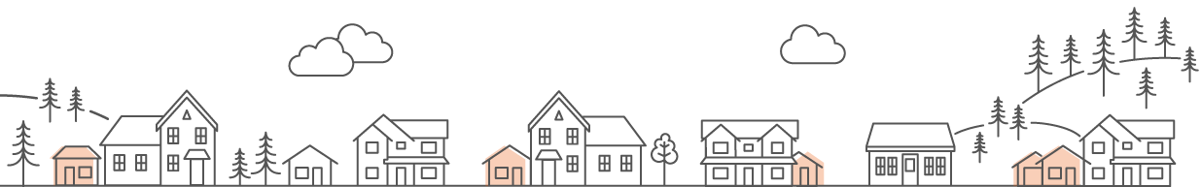
Together, these forms of residential infill can be added to our neighborhoods in low-impact ways to accommodate a variety of people at different stages of life. Each of these can be rented, or can be
sold as individual units to allow more households to own a small home.
Who lives in the small house in the backyard? The majority of people who live in ADUs are members of multi–generational families––typically the younger generation transitioning to moving out of their parents’ house or the older generation downsizing.

ENCOURAGING THE CONSTRUCTION OF NEW INFILL HOUSING SUCH AS ADUS AND MIDDLE HOUSING HAS MANY BENEFITS, INCLUDING:
- Adding to the diversity of housing options in our communities, which are needed for our state’s changing demographics, such as more seniors and smaller household sizes.
- Accommodating a variety of people at different stages of life, such as aging populations who wish to downsize without leaving their community.
- Providing housing that is typically more affordable than traditional single-family homes, allowing homeowners the opportunity to offset their mortgage or provide a home for their family members.
- Providing housing types that fit well with existing residential neighborhoods, sometimes correcting historic economic and racial exclusion by opening up single-family neighborhoods to more diverse housing and household types.
- Reducing climate impacts, including using less energy than traditional single-family homes, because they are smaller, and because they are in established neighborhoods, reducing total travel and preventing sprawl into forest and farmlands.
IN THE COMING YEARS, CITIES AND COUNTIES IN WASHINGTON STATE MUST ALLOW TWO ADUS PER LOT WITHIN ALL URBAN GROWTH AREAS
ADUs may be attached, detached, or a combination of both, or may be conversions of existing structures. Cities and counties may apply public health, safety, building code, and environmental permitting requirements to an ADU that would be applicable to the principal unit. Cities and counties in Washington:
- Must allow an ADU of at least 1,000 square feet and adjust other requirements.
- Must set parking requirements based on distance from transit and lot size.
- May not require the owner to occupy either the principal unit or the ADU.
- May not prohibit sale as independent units.
- May not charge more than 50% of impact fees charged for the principal unit.

Middle housing must be allowed in larger cities and those near them HB 1110 (laws of 2023) . Middle housing is expected to be “house scale”, with multiple units, generally in one building. Units per lot are expected as in the table below, unless zoning already permits higher densities, such as increasing housing around light rail stations.

Number of units per lot that must be allowed in predominantly residential zones | Base number of units  of middle housing that must be allowed per lot | Near a major transit stop: within ¼ mile  of transit | When affordable  units are provided
Cities with population of  at least 75,000 | 4 du/lot | 6 du/ lot within 1/4 mile walking distance of a major transit stop | 6 du/lot when 2 units  are affordable
Cities with population between 25,000 and 75,000 | 2 du/lot | 4 du/lot within 1/4 mile walking distance of a major transit stop | 4 du/lot when one unit  is affordable
Cities with population under 25,000 that are contiguous with Seattle, Tacoma, Spokane and Everett | 2 du/lot
WHAT COMES NEXT?
Investment in the development of middle housing and ADUs will vary according to the availability of infrastructure, such as sewer, and the size of lots where additional units may be developed. As communities start allowing more middle housing and ADUs, communities may see new detached ADUs in the yard next door, or may not see it at all as garages and basements are converted to living units. New housing may take the form of a duplex, or triplex, or a townhouse. You may be surprised how new neighbors can blend in while also enriching our communities.
Cities and counties across Washington are working to update
their plans and regulations to meet our housing needs.
Learn more about housing in your community, and how you
can help from the Washington State Department of Commerce
at www.commerce.wa.gov/planning-for-housing

Anne Aurelia Fritzel, AICP
Housing Programs manager, growth management services
Washington State Dept. of Commerce
anne.fritzel@commerce.wa.gov
(360) 259-5216

Washington State Department of Commerce Growth Management Periodic Update (commerce.wa.gov)
Washington State Legislature HB 1337 – 2023-24
Washington State Legislature HB 1110 – 2023-24

