
Planning for the Homeless & Lowest Income Households in Washington
AS DEMAND FOR HOUSING IN OUR STATE CONTINUES TO GROW, MANY WASHINGTONIANS ARE HAVING TROUBLE PAYING FOR
THEIR HOMES
 77%
of respondents to the Department of Commerce’s housing opinion survey agreed that rents are too
high. As housing costs continue to go up for all
of us, finding an affordable home to rent is out of the income range of more
than half of the people in our state.¹

Every person needs basic things, including food and shelter, but right now, these basic needs are out of reach for many of our neighbors. As rent and housing costs increase at a faster rate than income, the inability to afford housing also increases.
For many households, after paying for housing, they are making choices between: groceries and heat; childcare and healthcare; or transportation and education. It should be possible for everyone to pay for housing and have enough money left over for basic needs like food, childcare and gas. This impacts people in every community, even yours.
BECOMING HOMELESS IS EASIER THAN MANY OF US REALIZE
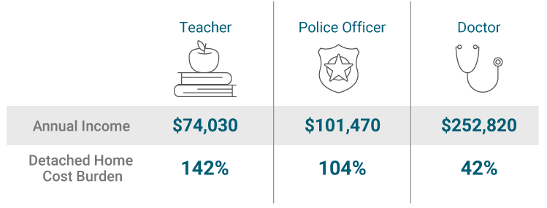
Losing your home is often as simple as a surprise bill, a medical expense, or job loss that wipes out savings, along with necessary rent or mortgage payments. Veterans, seniors, people with disabilities, and single-parent families are the most vulnerable, and are struggling the most in our current housing market.
Many working people in Washington can’t afford the cost of housing.
Source: Cascadia Partners Market Analysis, January 2023

Sou
The people we see camping in public spaces are a small percentage of the unhoused people in our communities. There are also many families, children, and elderly people experiencing homelessness or unstable housing situations that we don’t see at all.
They may depend on motels, family members, or even live in their cars because of high housing costs.
FOR THE FIRST TIME, OUR COMMUNITIES MUST PLAN FOR AND ACCOMMODATE HOUSING AFFORDABLE TO ALL INCOME BRACKETS
Creating housing solutions is a good investment and increases the quality of life for all of us. It moves people from public spaces into their own places, increasing their likelihood to stabilize. More supportive housing reduces the burden on expensive emergency systems like 911 response, emergency rooms, and jails. Although it might be hard to believe, our investments in permanent supportive housing have decreased chronic
homelessness by roughly 30% since 2007. Wrap around services, like counseling, subsidized rent, and access to healthcare provide opportunities for people to achieve stability and contribute more to their communities.
BUILDING MORE AFFORDABLE AND SUPPORTIVE HOUSING WILL ENSURE EVERYONE IN WASHINGTON
HAS A SAFE PLACE TO CALL HOME
SUPPORTIVE
HOUSING TYPES
Emergency: The housing for individuals and families who
are homeless or at urgent risk of becoming homeless. Consider a parent and child fleeing a violent situation, or someone who lost their job.
Transitional: The housing for individuals who need time-limited support to stabilize. Consider a veteran looking for a job, or a young adult who just exited the foster care system.
Permanent: The housing for individuals who need long-
term support to stabilize and stay in housing. Consider seniors and people with
chronic health issues.
Planning for our future requires us to look ahead and plan communities where everyone can find a suitable home, regardless of circumstance or stage of life. This means changing state and local rules and regulations to not only allow supportive housing, middle housing, and multifamily housing types, but even
incentivize them.
These changes in regulations set the stage for housing developments that create opportunities for our families, veterans, frontline workers, and teachers to find a place they can afford to live.
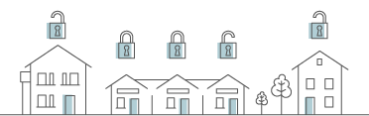
Detached housing is the most expensive housing type to build
and live in, but is also the most common housing type available. Attached housing types, like duplexes and fourplexes, are
more affordable.
Everyone in Washington deserves a home that is affordable and safe.
Supportive housing often involves 24/7 supports of someone, whether
onsite or by phone, and provides stability and helps people feel safe.

WE ALL HAVE A ROLE TO PLAY TO SECURE THIS FUTURE
State laws regarding housing are changing to encourage to remove barriers for both affordable and supportive housing, incentivize the construction of a variety of housing types, and to provide support to local jurisdictions to implement these changes. Regional governments and community-wide provider networks of supportive housing (also called Continuums of Care) are deeply involved in understanding the impacts of these changes within our communities so they can be ready to address housing needs. Cities, towns, and their residents are implementing these changes in their comprehensive plans, development regulations, and zoning. Without these changes, housing instability and homelessness will continue to increase. Changing local laws is a critical step to solving our state’s housing crisis.
Cities and counties across Washington are working to update
their plans and regulations to meet our housing needs.
Learn more about housing in your community, and how you
can help from the Washington State Department of Commerce
at www.commerce.wa.gov/planning-for-housing

Your name here
Title
Division, City, or County
name@commerce.wa.gov
(XXX) XXX-XXXX
Your name here
Your title goes here
Division, City, or County here
Firstname.lastname@commerce.wa.gov
Phone: XXX.XXX.XXXX

National Alliance to End Homelessness, Ending Chronic Homelessness Saves Taxpayers Money (endhomelessness.org)

