
Housing, Quality of Life, & the Environment in Washington State


MORE HOUSING AND BETTER QUALITY OF LIFE CAN HAPPEN TOGETHER
74%
of respondents statewide prefer new housing in walkable neighborhoods near town centers, according to the Department of Commerce’s 2022 Housing Survey.¹
More housing and diverse types of housing need to be added in Washington, while we provide a high quality of life
for people of all income levels, which includes protection of our
natural environment.
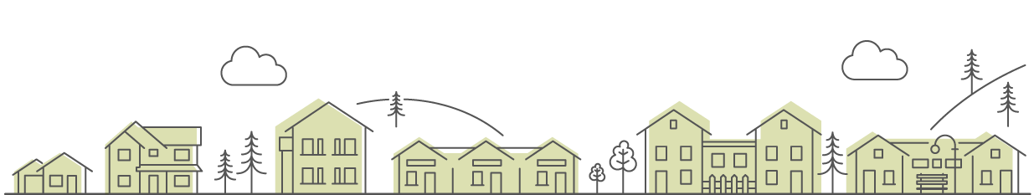
WELL-PLANNED COMMUNITIES ARE HEALTHY COMMUNITIES
Building diverse types of housing in our communities contributes to everyone’s quality of life––and promotes vibrant community centers and equitable access to the things we all need, like businesses and schools.

A high quality of life means our communities are healthy and vibrant, with attainable housing for all types and sizes of households and with abundant trees, parks, and open space, as well as economic vitality and jobs. It also means that we don’t spread growth into rural areas or into farm and forest lands—the heritage we want our children to have. Some people may wonder whether you can have more housing and still have healthy communities and a sustainable natural environment. The answer is yes––if you plan it well and follow up on those plans with incentives, regulations, and partnerships.
For example, in well-planned communities, many people can walk, bike, or take transit instead of driving in cars. This results in less energy usage, less air and water pollution, and lowers our climate impacts. Well-planned communities allow people to be closer to their jobs, schools, coffee shops, grocery stores and medical offices. That saves not only natural resources, but also time for people to spend with family and friends and do other activities. Well-planned communities are inclusive, offering opportunities for people with different backgrounds and incomes.

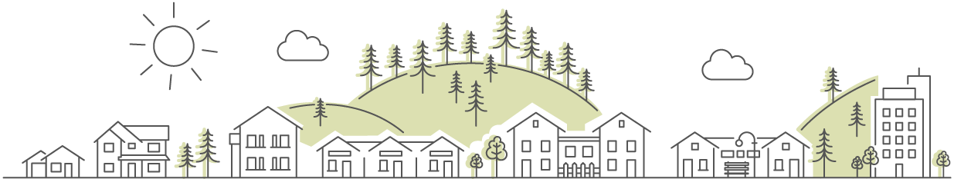
Building more housing doesn’t mean less trees or fewer green spaces in Washington.
COMMUNITIES IN WASHINGTON ARE WORKING TO ACHIEVE MORE HOUSING AND A
HEALTHY ENVIRONMENT
Cities and counties in Washington must plan and adopt regulations under state laws (such as the Growth Management Act) to help achieve more housing and a healthy environment over the long term.
Most of them, starting with cities and counties in the central Puget Sound region, must update their plans and regulations to accommodate more housing and meet other needs, with the first set of due dates by the end of 2024 and for some housing regulations by July 2025. That work has started in many communities throughout our state.
Cities and counties across Washington are working to update
their plans and regulations to meet our housing needs.
Learn more about housing in your community, and how you
can help from the Washington State Department of Commerce
at www.commerce.wa.gov/planning-for-housing

Your name here
Title
Division, City, or County
name@commerce.wa.gov
(XXX) XXX-XXXX

Puget Sound Regional Council & Washington State Department of Commerce December 2022 Housing Survey (psrc.org)

